Issue Topic: “Artificial Intelligence & Machine Learning in Computer Vision Applications “

Title of Paper

First Author
University
Department
E-mail:
Third Author
University
Department
E-mail:
Second Author
University
Department
E-mail:
Fourth Author
University
Department
E-mail:

Abstract—The field of medicine is difficult to compare between different countries, as the development and their focus are individual and faces unique problems. Possible solutions provided by the western world usually require higher financial expenses and intensive training of workers involved in the medical field. Experience gathered in Mongolia lead to the suggestion that the involvement of computer technology can create benefits for the healthcare sector without extensive costs and intensive training. The missing experience of medical workers can be covered with computed technology that is designed to support them in making correct decisions. At the same time these technologies will never be able to fully replace workers and therefore should not lead to dismissal in the healthcare sector.
Keywords—medical IT; developing countries; hospital information system; electronic health record; medical image processing; computer aided systems.

Introduction
In spite of global importance of Medicine there are enormous differences in quality and quantity on the national level. Especially developing countries face problems due to financial limitations and missing experience [1]. Engineers working in the field of medicine try to consider all technical aspects for their potential benefit in the medical context. Many technical solutions are expensive and require a proper training of the users before they can be declared as useful in medicine. There, the same limitations that also affected the medicine in general, occur again. But another promising field that is related to technological advances of the recent years, might have the potential to support medicine in developing countries without the need for high expenses and time intensive preparations: Computer technology can offer many interesting possibilities in the field of medicine. The question is whether the possibilities of medical IT is fitting on the needs of developing countries.

Health Information Technology
Before it is possible to truly understand the potentials offered by modern medical information technology, an overview must be given of the different ideas and purposes of technologies that are already available.

Hospital Information technology
There are different technologies, that are already in use in a hospital setting to support the work of the doctors, workers and the management of the hospital. The intentions of these solutions are usually to collect all relevant data about the hospital patients and to create different overviews of relevant information, specially designed for separated professions and departments.

Hospital Information System (HIS): A general management system for hospitals to identify and register patients and to attach attributes to them. The resulting database includes medical information such as anamnesis, measurement results, differential diagnosis, medical images and therapy plans as well as information that is relevant for the appropriate management for the patient (e.g. contact person, responsible doctor or appointments for diagnostics or threatments). A full access to all of these patient information would be an enormous ethical problem; therefore the HIS has a number of different interfaces, that only allow a limited output of data, that is considered to be relevant for the person that is active on the computer.

Radiology Information System (RIS):A sub-system of the HIS, specialized on the data collection and patient management in a Radiology department. It provides the necessery connections to Medical imaging equipment for the data acquisition. The collected data is mainly based on images for diagnosis made by radiologic equipment as well as the diagnosis reports made by the radiologists.

Picture Archive and Communication System (PACS): A computer system specialized on storage of patient images. In hospitals a PACS system allows the doctors to view the digital radiology images on their office computers due to a network connection, that can pass these patient information to every authorized computer system. In different countries the network grew larger during the last years with different hospitals using the same network for a fast exchange of information and duties. For example: For emergency cases every hospital needs to have a nightshift working. Also radiologists are needed to make diagnosis based on emergency CT images. If hospitals share the same PACS network, then only one radiologist is necessary for the complete network.

Computer – Radiology Device – Network: The network that connects radiologic devices such as CT or MRI with the computer network system and the PACS. This connection is an important aspect of Medical IT because without it there is no possibility to get patient images into the system. But there are also security considerations that require a special attention: While a normal network only has to be standardized according to ISO/IEC 20000 - Information technology - Service management [2], there are additional standards necessary when Medical Devices gets included into the system: ISO 14971 – Application of Risk management to medical devices and ISO/IEC 80001 - Application of risk management for IT-networks incorporating medical devices [3]. Both standards say that it is necessary for the Hospital IT network provider to take care of the risk management. The manufacturer of the medical device does not need to take special actions for the protection of the device from threats that come through the network connection.

Electronic health record (EHR): A storage system for all medically relevant information. It is possible to save these information on a card/ stick, so the patient can take all these information with him/her in a safe storage that only can be accessed by medical doctors that need to know background information about previous anamnesis, treatment, illnesses and medications to treat the patient correct. These information can be used in addition, when made anonymous, to offer doctors, teachers in medicine and researchers an opportunity to collect data and case studies for training or statistics.

Artificial Intelligence (AI) in Medicine
A new aspect of medical information technology is the use of algorithms and artificial intelligence (AI) for the processing of medical information. This offers new possibilities that can support medical doctors in making the correct decisions. It is important to mention that no system could ever replace an experienced and well educated medical doctor, but it can support him/her by providing information and suggestions. In that way a medical doctor can use his/her time more effectively for work that clearly requires his/her personal attention.
AI systems in medicine require a higher level of computation within the hospital and therefore higher costs for the stronger computers that are used.

Computer aided detection (CADe) / Computer aided diagnosis (CADx): A computer program / algorithm that can serach automatical for hints and symptoms written in the patient data. It then can highlight these information to focus the medical doctors attention on these aspects. In terms of radiology it is possible that medical image processing software can analyze the image and prepare markings for every unusual finding [4]. The analysis of digital data is an important work to detect hidden symptoms that are important for the differential diagnosis.

Clinical decision support system (CDSS): A clinical decision support system is a computer program with database, that can help the doctor to make correct decisions. As an example it is possible to insert the symptoms found in the anamnesis and medical inspection and the computer system can give suggestions for a differential diagnosis. As there are many different illnesses described in books by medical doctors, it is difficult for the medical doctor to know all possible illnesses by heart.
Also, suggestions for medication as a treatment for diagnosed illnesses can be given by the computer system. This can help the medical doctor to safe time with reading in specialized books and helps to avoid possible mistakes.

Developing countries and case study: Mongolia
Developing countries are difficult to define. In fact, even the United Nations declare in their reports that there is no universal list of criteria for a definition and therefore no list of countries, that are considered as such. The only definition given by the United Nations is the definition of Least Developed Countries (LDC). On the official list there are currently 47 countries listed, that are considered “least developed” [5]. In a dataset provided by the United Nations there are 145 countries listed (neither USA, Canada, Japan nor countries of the European Union) but it contains data of the “Republic of Korea” as well as of “Singapore” and “Israel” [6]. Obviously these three countries have different problems than most of the countries, that are considered “developing”. When taking the information from the Human Development Report 2016 [7] it is clearly to see, that these countries are considered to have a “very high human development”. Singapore is on Rank 5, the Republic of Korea on Rank 18 and Israel on Rank 19, while France (Rank 21), Austria (Rank 24) or Spain (Rank 27) are even lower.

General development
As there is no clear definition about developing countries, it is difficult to speak about their general development and current problems, as the development of these countries is spread over many different stages. Therefore in this article the Human Development Index [7] is taken into account as a definition of countries that are in a stage of current development. This Human Development Index (HDI) takes different health care information (e.g. life expectancy) as well as educational data (e.g. expected and current years of school education). It shows that countries with comparable statistics can be very different in their human development (see table 1).
- Example of country statistics
Country name | Country statistics
Country name | Population | Size | HDI
Belgium | 11,370,968ª | 30,528 km² ^{c} | 22 ^{d}
Haiti | 10,911,819^{b} | 27,750 km² ^{c} | 163 ^{d}
- http://www.ibz.rrn.fgov.be/fileadmin/user_upload/fr/pop/statistiques/stat-1-1_f.pdf
- http://www.ihsi.ht/pdf/projection/Estimat_PopTotal_18ans_Menag2015.pdf
- https://unstats.un.org/Unsd/demographic/products/dyb/dyb2015/Table03.pdf
- http://hdr.undp.org/sites/default/files/2016_human_development_report.pdf

Healthcare development
In the field of Medicine the countries of the United Nations list are as different as they are in general. The biggest trouble of developing countries is that international standards for hospital environments and medical procedures are often far away from the current situation in these counties. Examples of these differences are:
- Old vs. new medical devices: New devices must meet the requirements given in the current standards, old equipment does not need to be updated. Poor countries use old equipment (in many cases second hand devices) and do not know whether they work correct or not.
- Old vs. new buildings: Many of the buildings used in poor countries are old constructions originally planned for different purposes. Safety standards and management standards for medicine are difficult to meet with these old constructions.
- Information Technology: Between the different countries there are huge differences in the use of information technology. While some countries have country wide internet connection and a wide range of computers and mobile devices, other countries cannot even cover the electricity supply in all areas of the country.
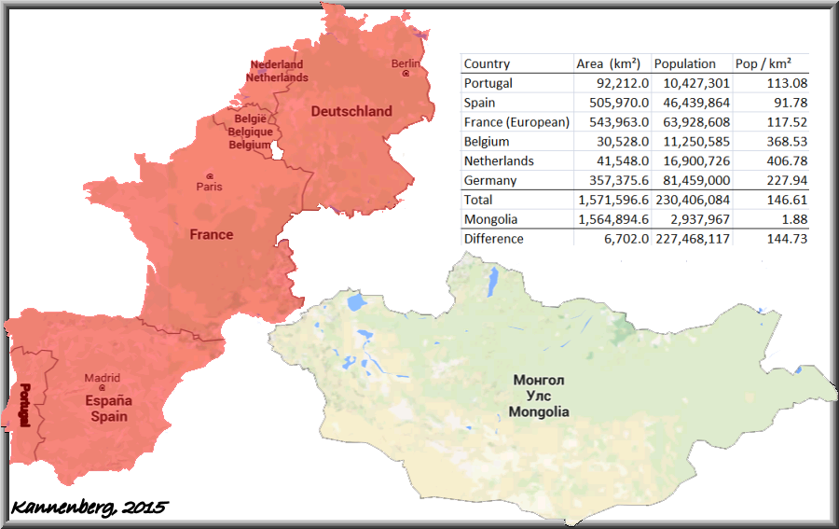
Figure 1: Mongolia in comparison with western Europe.

Case study Mongolia
Mongolia is a landlocked country in Central/ Eastern Asia with only the Russian Federation and the People’s Republic of China as its neighbours. On the map seemingly small it still has the size of western Europe (Portugal, Spain, France, Belgium, Netherlands and Germany together, see figure 1).
In average the height of the country is 1580 meters above the sea level, but varies strongly from 532 meters above the sea level up to 4374 meters above sea level [8]. It is divided into 21 different districts that have a very different population density each. With 0.38 people per square kilometre the Aimag of Govi-Altai had the lowest population density of all Aimags in 2012. Many areas in Mongolia can be described as rural areas without electricity or sanitation. The situation of the population, who are often nomads travelling with their animals, makes it difficult to analyze and improve according to projects such as the “Millennium Development Goals” that was made by the United Nations to improve the life situation of all people on Earth. As a result, the Mongolian Minister for Economic Development wrote in a progress report in 2013:
"However, the targets of reducing poverty by half, increasing employment, getting all children primary education, reversing the spread of tuberculosis, protecting the environment require additional effort."
Millennium Development Goals Fifth National Progress Report 2013, Foreword of BATBAYAR Nyamjav,
Minister for Economic Development. page 7 [9].
Similar to other developing countries the financial expenses are often spend for public and well recognizable projects, that are intended to improve the prestige of the country. The difficulties that occur in this situation are a lack of “hidden investments” e.g. for the improvement of electricity or sanitation systems. This often leads to problems where high quality devices and systems are acquired for the country but cannot be used properly because the infrastructure for a safe connection and operation of the technology is missing and often the potential users are not properly trained and experienced with such technology.

Results and conclusion
Different projects are currently running in Mongolia to improve the healthcare situation in the country. One of these projects is the “Bio-Engineering for human sustainable development in Mongolia” project, partially supported by the Higher Engineering Education Development (M-JEED) Project funded by the Japan International Cooperation Agency (JICA) [10]. It is a Mongolian - Japanese joint project with a focus on biomechanical considerations of the Mongolian population. The challenge of the project is to collect evaluable amounts of patient data to be able to create statistics of the Mongolian anatomy, which is necessary for the biomechanical research that is intended.
In order to be able to collect these patient information, the project group promotes the Idea of regional / national PACS systems, that connect the different hospitals in Mongolia and can develop into a save and stable database for the ongoing research [11]. Regional / National PACS systems have been proven to be effective not only for research purpose but also for general management and information exchange between the hospitals. In Great Britain for example there have been a construction of regional PACS systems for a longer period of time [12].
The different regions of the British Isles (figure 2) have their own PACS systems for the exchange of information. Due to the high population in Great Britain it is not reasonable to have one national system. But in Mongolia the population will not increase rapidly and reach the limitations of national PACS networks [11].
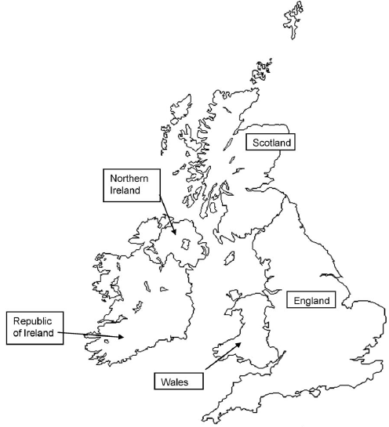
Figure 2: The British Isles and its regions [12]
Limitations for national networks in Mongolia are the lack of infrastructure in rural areas of the country. Therefore it is suggested that regional PACS projects should be developed in areas of Mongolia, where the required infrastructure is available, while other areas focus their attention on reaching these requirements. Therefore a first regional PACS system should be developed in the capital of Mongolia, Ulaanbaatar, where about 50% of the Mongolian population is living.
The field of Artificial Intelligence (AI) in medicine is not commonly known in Mongolia and should be introduced on a wider scale within the medical university and the private hospitals, which have a higher level of computerization within their working space.
Acknowledgment
The authors would like to thank all members of the Mongolian-Japanese joint program “Bio-Engineering for human sustainable development in Mongolia”. Their participation in research and data collection has been a great help in promoting the National PACS idea in Mongolia.
This research is partially supported by the Higher Engineering Education Development (M-JEED) Project based on Japan International Cooperation Agency (JICA) Loan Agreement No. MON P-11 dated March 21, 2014.

References
[1] M.W.Duenser, O.Bataar, G.Tsenddorj, et al., "Differences in critical care practice between an industrialized and a developing country", Wien Klin Wochenschr, 2008, vol.120, pp.600–607.
[2] ISO/IEC 20000 - Information technology - Service management International Electrical Commission. Geneva 2010.
[3] ISO/IEC 80001 - Application of risk management for it-networks incorporating medical devices. International Electrical Commission. Geneva 2010.
[4] C.A.Schneider, W.S.Rasband, K.W.Eliceiri, "NIH Image to ImageJ: 25 years of image analysis", Nature Methods, vol.9, 2012, pp.671–675.
[5] Committee for Development Policy, "List of least developed countries". Accessed: October 29. 2017. Available online at https://www.un.org/ development/desa/dpad/wp-content/uploads/sites/45/publication /ldc_list.pdf
[6] Committee for Development Policy, "Complete dataset", Accessed October 29. 2017 Available online at https://www.un.org/development/ desa/dpad/wp-content/uploads/sites/45/page/LDC_data.xls
[7] United Nations Development Programme, "The Human Development Report 2016". Accessed October 29. 2017 Available online at http://hdr.undp.org/sites/default/files/2016_human_development_report.pdf
[8] National Statistical Office of Mongolia. Mongolian statistical yearbook, 2012. Ulaanbaatar, Mongolia: National Statistical Office of Mongolia; 2013.
[9] Ministry of Economic Development. Millennium Development Goals Fifth National Progress Report 2013, Ulaanbaatar, Mongolia. September 2013.
[10] S.Kannenberg, D.Ganbat, F.Ueberle, "Bio-Engineering for human sustainable development in Mongolia", Mongolian Congress on Radiology, September 15th – 17th 2016.
[11] S.Kannenberg, D.Ganbat D, B.Baljinnyam, F.Ueberle, "Potential of National PACS concepts in Mongolia", Scientific transactions, Mongolian University of Science and Technology, vol.2017/10/215, July 2017.
[12] L.N.Sutton, "PACS and diagnostic imaging service delivery—A UK perspective", European Journal of Radiology, vol.78(2), 2011, pp. 243-249.

Copyright © 2020 by ESS Journal

